**Session 2**

**-**

**Control of GPIO, LED,**

**push button**

**Author:** Guillermo Cortés Orellana

**Teacher:** Tomáš Frýza



Lab assignment

1. **LED example**

* Tables for DDRB, PORTB, and their combination

|  |  |
| --- | --- |
| DDRB | Description |
| 0 | Input Pin |
| 1 | Output Pin |

|  |  |
| --- | --- |
| PORTB | Description |
| 0 | Output low value |
| 1 | Output high value |

|  |  |  |  |  |
| --- | --- | --- | --- | --- |
| DDRB | PORTB | Direction | Internal pull-up resistor | Description |
| 0 | 0 | Input | NO | Tri-state (Hi-Z) |
| 0 | 1 | Input | YES | Pxn will source current if ext. Pulled low |
| 1 | 0 | Output | NO | Output Low |
| 1 | 1 | Output | NO | Outout High |

* Table with input/output pins available on ATmega328P

|  |  |  |
| --- | --- | --- |
| PORT | Pin | Input/Output usage |
| A | x | Doesn’t contain PORT A |
| B | 0 | Yes (Pin 8) |
| B | 1 | Yes (Pin -9) |
| B | 2 | Yes (Pin -10) |
| B | 3 | Yes (Pin -11) |
| B | 4 | Yes (Pin 12) |
| B | 5 | Yes (Pin 13) |
| B | 6 | NO |
| B | 7 | NO |

|  |  |  |
| --- | --- | --- |
| PORT | Pin | Input/Output usage |
| C | 0 | Yes (Pin A0) |
| C | 1 | Yes (Pin A1) |
| C | 2 | Yes (Pin A2) |
| C | 3 | Yes (Pin A3) |
| C | 4 | Yes (Pin A4) |
| C | 5 | Yes (Pin A5) |
| C | 6 | NO |
| C | 7 | NO |

|  |  |  |
| --- | --- | --- |
| PORT | Pin | Input/Output usage |
| D | 0 | Yes (Pin RX <- 0) |
| D | 1 | Yes (Pin TX -> 1) |
| D | 2 | Yes (Pin 2) |
| D | 3 | Yes (Pin -3) |
| D | 4 | Yes (Pin 4) |
| D | 5 | Yes (Pin -5) |
| D | 6 | Yes (Pin -6) |
| D | 7 | Yes (Pin 7) |

* C code with two LEDs and push Button

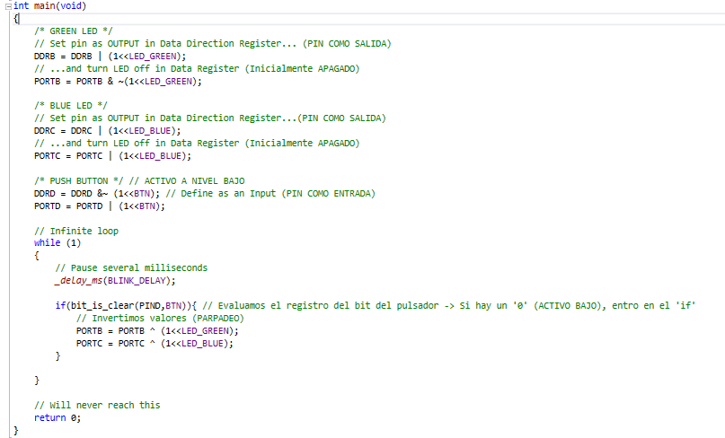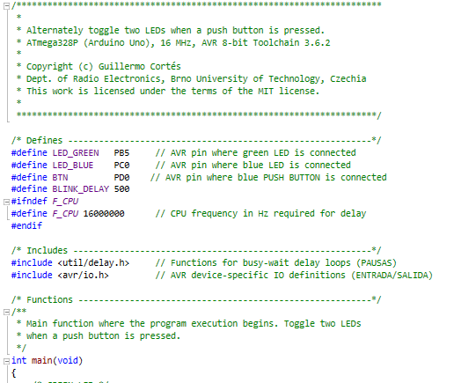

You can find the code on my GitHub:

https://github.com/GuicoRM/Digital-Electronics-2

* Screenshot of SimulIDE circuit

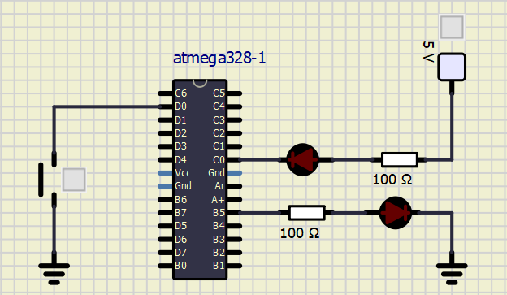

1. **Knight Rider application**

* C code

**Note 1:** all LEDs are **RED** in order to simúlate ‘Knight Rider style’

**Note 2:** LED 1 is designed in active-low way

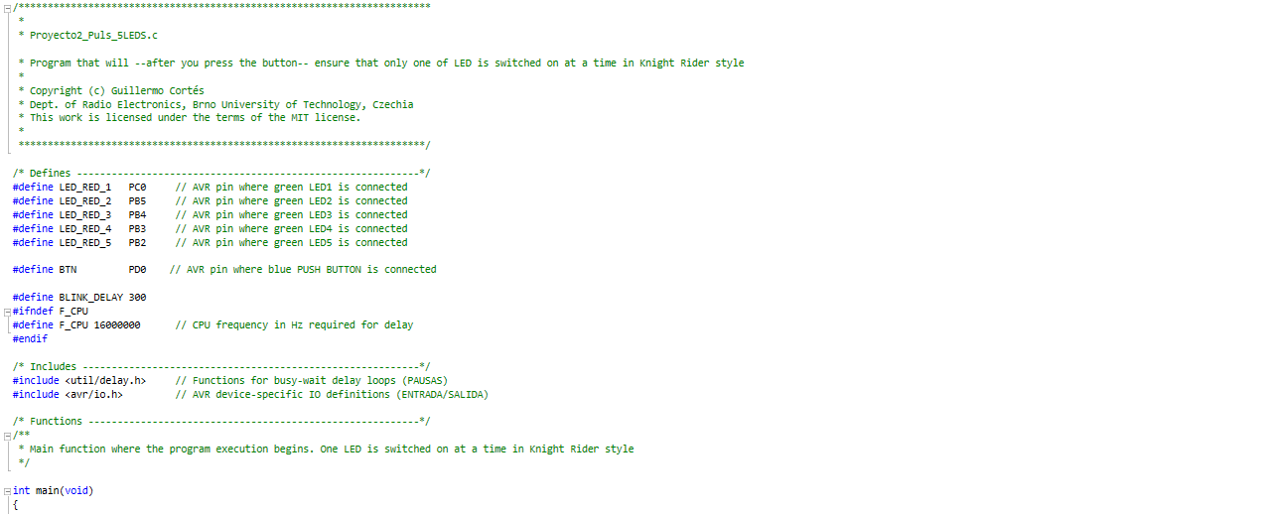**Note 3:** LED 2, LED 3, LED 4 and LED 5 are designed in active-high way

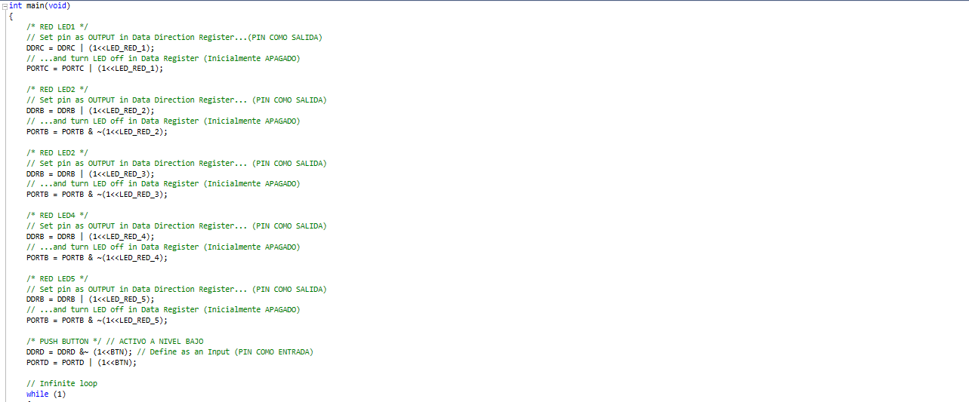

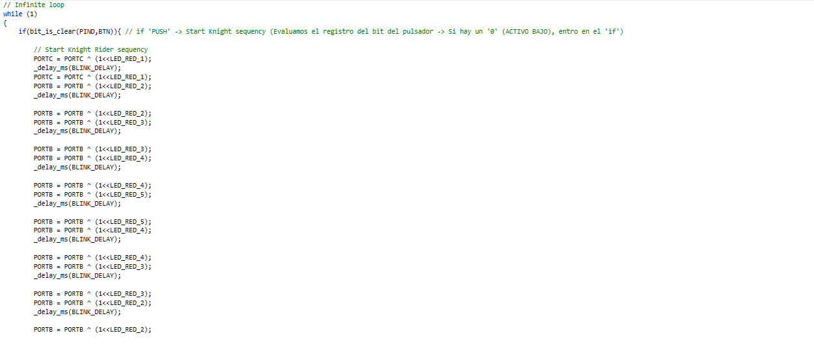

You can find the code on my GitHub:

https://github.com/GuicoRM/Digital-Electronics-2

* Screenshot of SimulIDE circuit

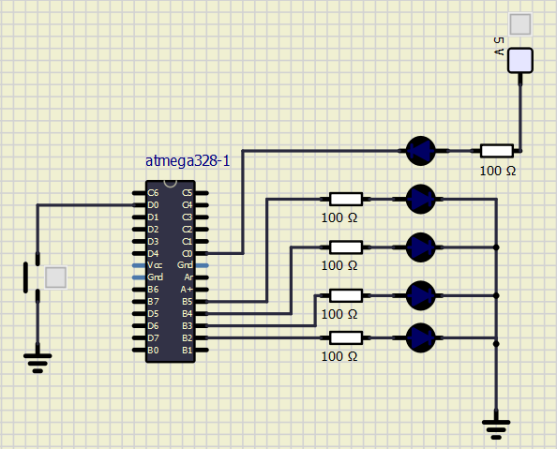

LED 2 – LED 5

LED 1